Pointers
16-11-25
Aim – Write a program to demonstrate pointers, pointer to pointer and pointer to array
Theory –
Pointers store memory addresses of variables, enabling efficient data access. A pointer to pointer holds the address of another pointer, allowing multiple indirection levels. A pointer to array stores the address of an entire array, helping manage multi-element data structures and multidimensional arrays effectively.
A1.
#include <stdio.h>
void main() {
int n = 10;
int *ptr;
ptr = &n;
printf("Value of n : %d\n", n);
printf("Value via *ptr : %d\n", *ptr);
}
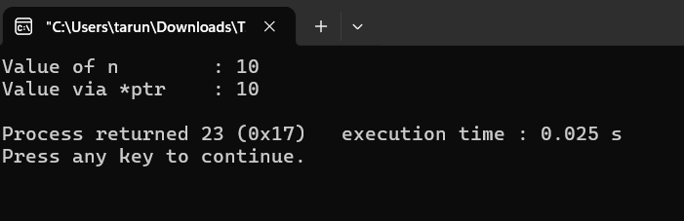
A2.
#include <stdio.h>
void main() {
int n = 10;
int *ptr;
int **pptr;
ptr = &n;
pptr = &ptr;
printf("Value of n : %d\n", n);
printf("Value via *ptr : %d\n", *ptr);
printf("Value via **pptr : %d\n", **pptr);
**pptr = 50;
printf("\nAfter modification:\n");
printf("Value of n : %d\n", n);
printf("Value via *ptr : %d\n", *ptr);
printf("Value via **pptr : %d\n", **pptr);
}
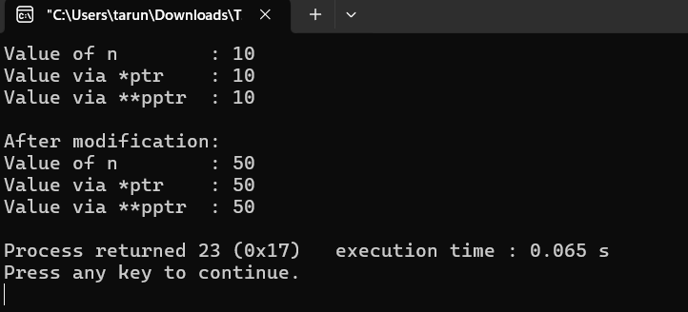
A3.
#include <stdio.h>
void main() {
int arr[5] = {10, 20, 30, 40, 50};
int (*p)[5] = &arr;
printf("Accessing array using pointer to array:\n");
for (int i = 0; i < 5; i++) {
printf("(*p)[%d] = %d\n", i, (*p)[i]);
}
}
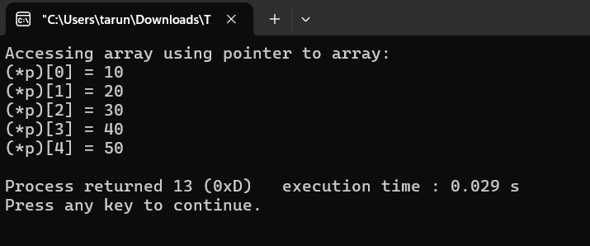
Conclusion
I learnt that pointers store variable addresses. Pointer to pointer stores another pointer’s address for multi-level access. Pointer to array stores the address of an entire array, helping manage multiple elements efficiently.

